Journeys to Bethlehem Wk 2 Sue Martin travels to bethlehem
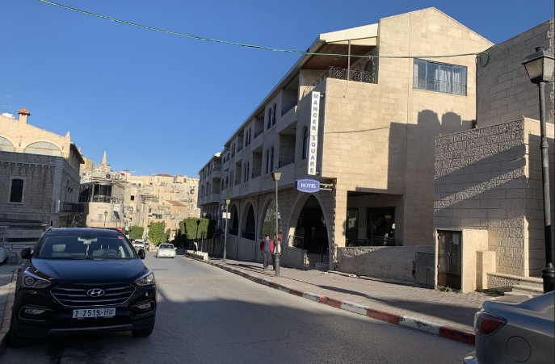

Manger Square Hotel 2020(SM)

Carol o little town of Bethlehem
A modern-day pilgrimage to the Holy Land always includes Bethlehem, but often the journey to Bethlehem comes after an introduction to other places in Israel. Bethlehem can be a chaotic and challenging place for tourists. It is situated close to Jerusalem with heavily concreted walls to separate the Palestinian Refugee Camps from the Israelis. Geographically it is virtually at the centre of the world, a meeting place for the continents of Africa, Asia and Europe
In our advent journey this week we will look at Bethlehem through my eyes, as I travelled as a pilgrim in 2015 and 2020.
Both my pilgrimages were with the Diocese of Norwich, firstly led by Rt Reverend Graham James, Bishop of Norwich in 2020, and secondly led by Rt Reverend Jonathan Meyrich, then Bishop of Lynn in 2020 and The Very Reverend Jane Hedges, Dean of Norwich Cathedral. We were met and led by guides who are Christians based in Israel, and both times their knowledge and information were invaluable in building a fuller picture of this place now and in the past.
Bethlehem is the city where Jesus was born, the place where the shepherds lived, the place where the star shone so brightly. Today, it is a city of surprises. Our hotel was very close to Manger Square which at 7.00amt would slowly be coming to life. The coffee shops would open, selling breakfast, The Christmas shop would open from 10.00 until 9pm. But every morning the sky was blue, and it felt good to be in that place.
On our journeys we visited the Church of the Nativity, Manger Square, Shepherds’ Fields, and Palestinian Refugee camps. We learnt that Christians are very much in the minority, but that in the eyes of the people we met they all wanted to share Bethlehem in the message that God brings light into this world.
We will look at the places on the journey in Bethlehem, we will talk about what it means to be in the very place where Jesus was born, and we will have an insight into Bethlehem and its place in Israel today.Rev’d Sue Martin Gayton, Grimston and Massingham Benefice, Diocese of Norwich, http://www.faithgoeswalkabout.org/walkaboutjerusalem2020/

